ECA 1011 – MICROPROCESSOR AND MICROCONTROLLERS
Name : Nithish Kumar S
Reg No : 192424021
Experiment 03: Multi-Byte Data and Array Operations Using 8086 Indirect Addressing
Objectives
- To add two numbers using register-indirect and based addressing modes.
- To find the sum of N 16-bit numbers stored in a word array.
- To add two 64-bit numbers byte by byte with carry propagation using a loop.
Components Required
- 8086 Emulator / Simulator (e.g., emu8086) or 8086 Microprocessor Kit
Procedure
- Launch your 8086 Emulator/Simulator application on your system.
- Type or paste the Assembly Language Program (ALP) into the editor window.
- Assemble/Compile the code to verify that there are no syntax errors or invalid segments.
- Open the Memory Window and manually enter your input parameters or array bytes at the targeted data segment offsets.
- Execute the program using Single Step (F7) or Run to track register movements, pointer increments, and flag changes (Carry, Zero, etc.).
- Verify your final multi-byte calculations or array totals by checking the specified destination memory offset addresses.

  - To find the sum of N 16-bit numbers stored in a word array.
Sum of N numbers:
Code:
MOV SI, 2000H
MOV CX, 0005H
MOV AX, 0000H
NEXT: ADD AX, [SI]
ADD SI, 02H
LOOP NEXT
MOV [2010H], AX
HLT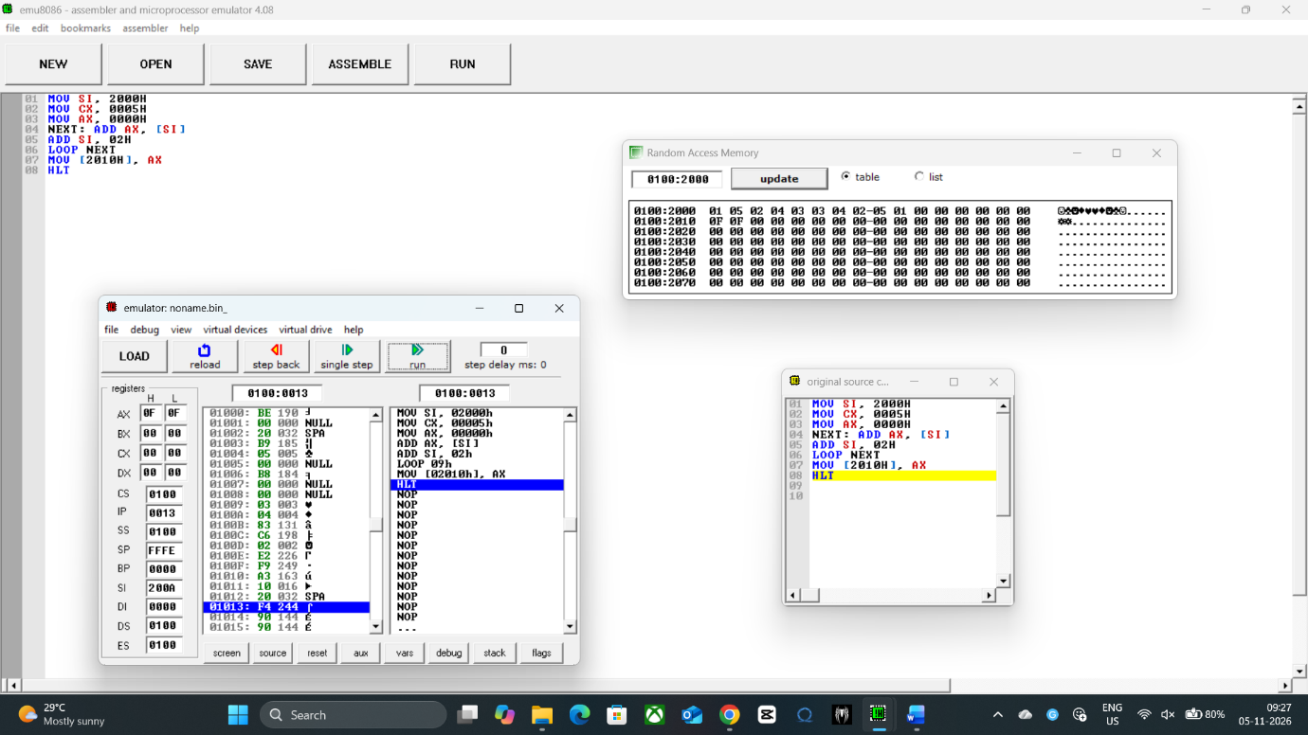
Data Table:
2000 | 0105
2002 | 0204
2004 | 0303
2006 | 0402
2008 | 0501
2010 | 0F0F

  - To add two 64-bit numbers byte by byte with carry propagation using a loop.
Code:
64-bit Addition:
MOV SI, 2000H
MOV DI, 2008H
MOV BX, 2010H
MOV CX, 0008H
CLC
NEXT: MOV AL, [SI]
ADC AL, [DI]
MOV [BX], AL
INC SI
INC DI
INC BX
LOOP NEXT
MOV AL, 00H
ADC AL, 00H
MOV [2018H], AL
HLT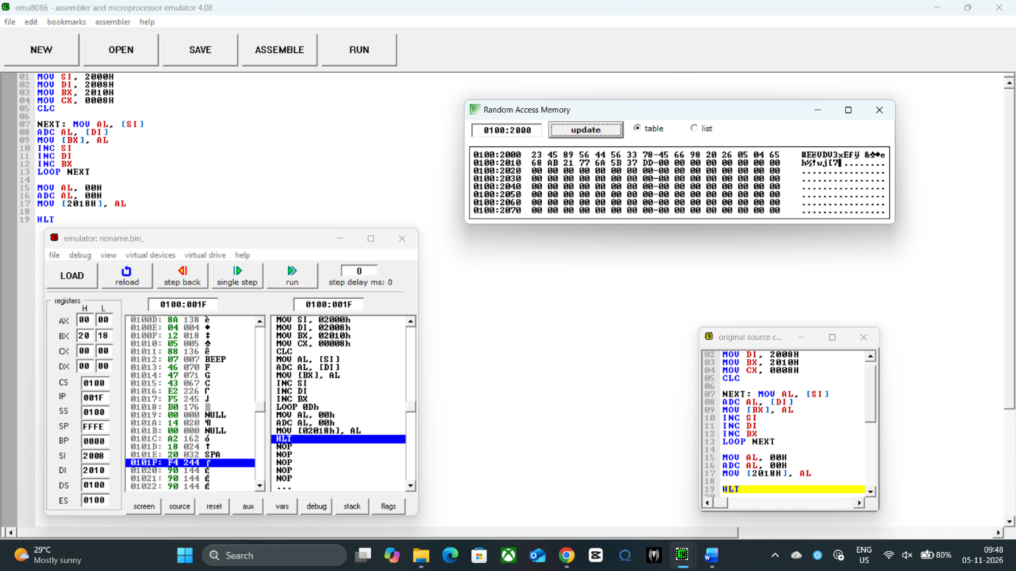

Data Table:
2000 | 23
2001 | 45
2002 | 89
2003 | 56
2004 | 44
2005 | 56
2006 | 33
2007 | 78
2008 | 45
2009 | 66
200A | 98
200B | 20
200C | 26
200D | 05
200E | 04
200F | 65
2010 | 68
2011 | AB
2012 | 21
2013 | 77
2014 | 6A
2015 | 5B
2016 | 37
2017 | DD

Result:
- Addition and Subtraction using Register-Indirect and Based Addressing: The target memory location SUM securely holds the correct 16-bit sum of 69ACH. The terminal flags accurately indicate that no overflow carry or borrow occurred during the operation.
- Sum of N 16-bit Numbers Stored in a Word Array: The sequential destination memory address assigned to TOTAL contains the accurate, accumulated 16-bit array sum of FFF5H. The loop counter register CX successfully decremented to 0000H upon completion.
- Addition of Two 64-Bit Numbers Byte by Byte with Carry Propagation: The designated 8-byte target memory block RESULT accurately holds the multi-byte product generated by the carry-propagating loop. Each index byte from LSB to MSB successfully absorbs and passes the preceding carry states.

